**Keerthi Sweets Project Report Template**

**1 INTRODUCTION**

* 1. Overview

A brief description about your project

* 1. Purpose

The use of this project. What can be achieved using this.

1. **problem Definition & Design Thinking**

2.1 Emathy Map

Paste the empathy map screenshot

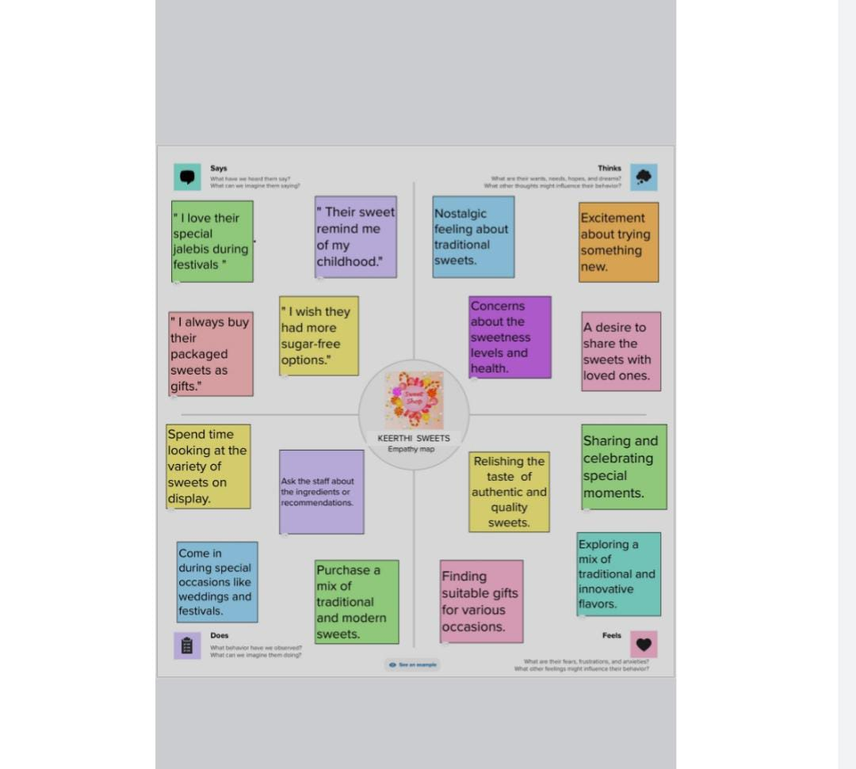

2.2 Ideation & brainstorming map

Paste theideation & brainstorming map screenshot.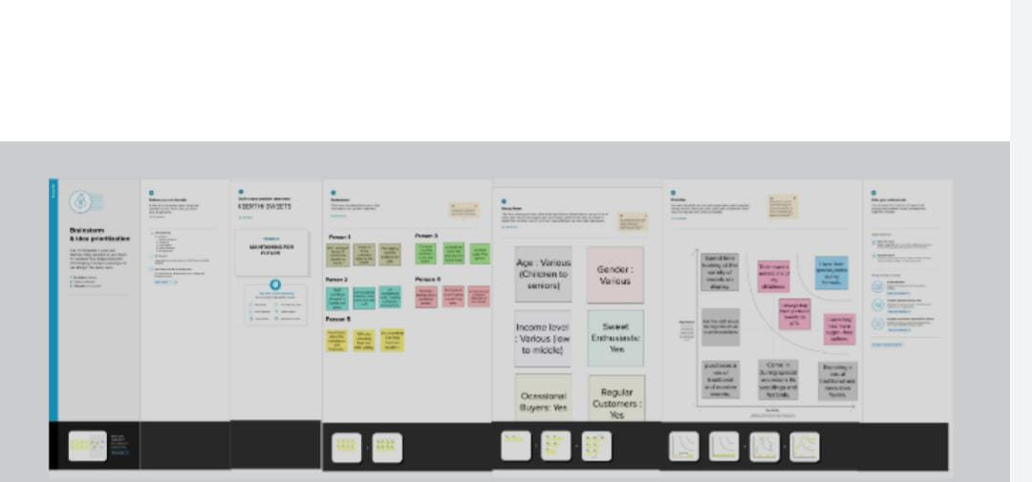

3.**RESULT**

Final fndings (Output) of the project along with screenshots.

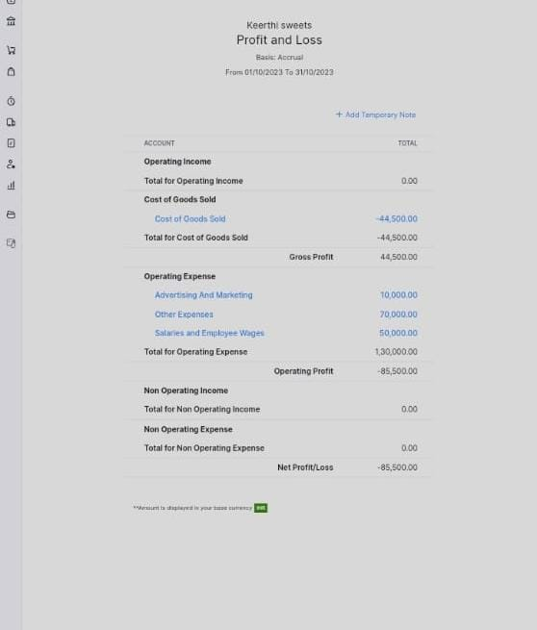

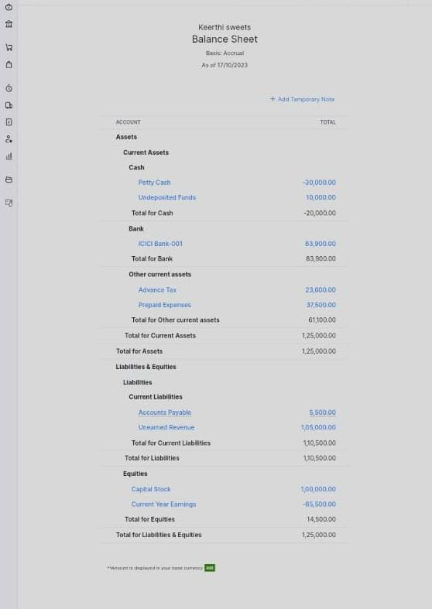

1. **ADVANTAGES** **&** **DISADVANTAGES**

List o advantages and disadvantages of the proposed solution

**Advantages:**

* Invoicing And Billing. ...
* Online Payments. ...
* Expense Tracking. ...
* Project Management & Timesheets. ...
* Inventory Management. ...
* VAT Tax Compliance. ...
* Report Generation. ...
* Reduce Overall Costs

**Disadvantges**:

Integration with other applications and tools can be limited, which can make it challenging to work with other business solutions.

1. **APPLICATIONS**

The areas where this solution canbe applied

* Mural link: <https://www.mural.com/>
* GitHub link: <http://www.github.com/>
* Zoho books link; <http://books.zoho.com/>
* Naan Mudhalvan link: <https://www.goole.com/url?q=https://portal.naanmudhalvan>
* Smart Internz link: <http://nm.smartinternz.com/>

**6**  **CONCLUSION**

Concusion summarizing the entire work and findings.

**7 FUTURE SCOPE**

Enhancements that can be made in the future.

1. **APPENDIX**
2. Source Code

Attach the code for thessolution built.

Dashboard link

<https://drive.google.com/file/d/150VB2jJ-WLr7pOrFWdZQnVzidNvKYbQ5/view?usp=drivesdk>

Storylink

<https://drive.google.com/file/d/157_P4T3Ho6UL1YeXfqY8uyKOuABwwagw/view?usp=drivesdk>